Firmware flashing to Pegasus Star
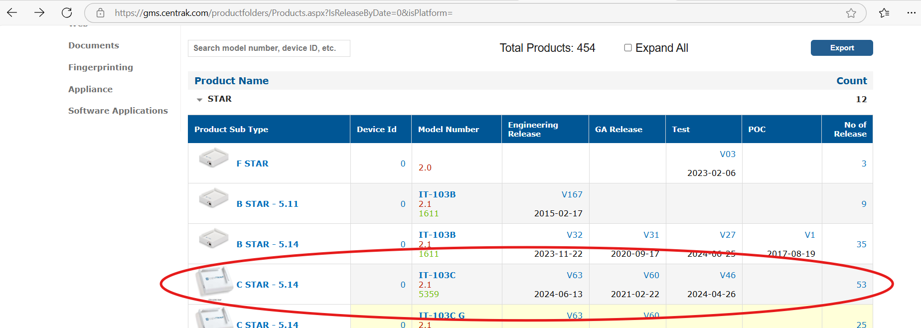
Star Flashing
Need to change the MAC ID of your star
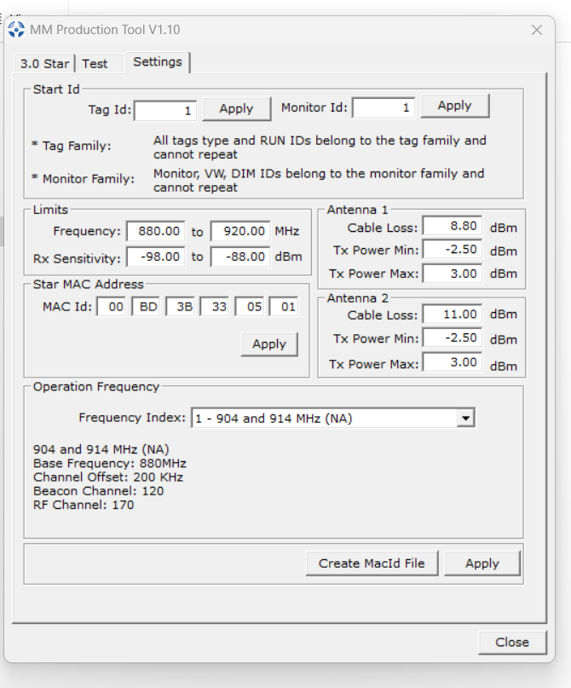

Click apply button
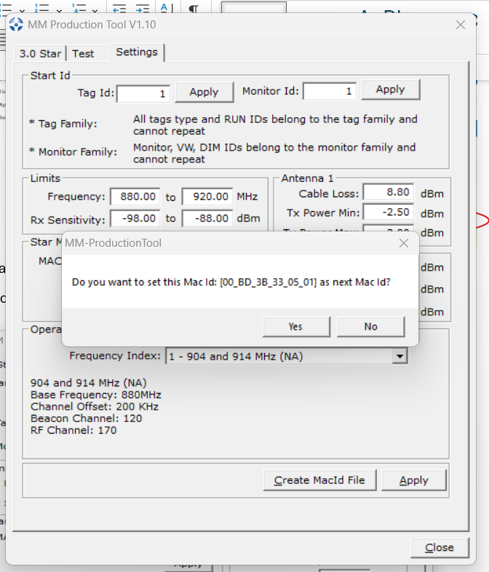
Click yes button
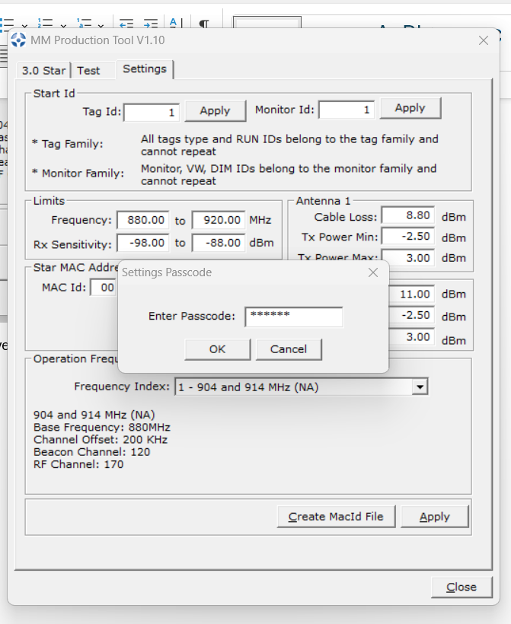
Password is RPI123

Goto 3.0 Star options and set Frequency to 880

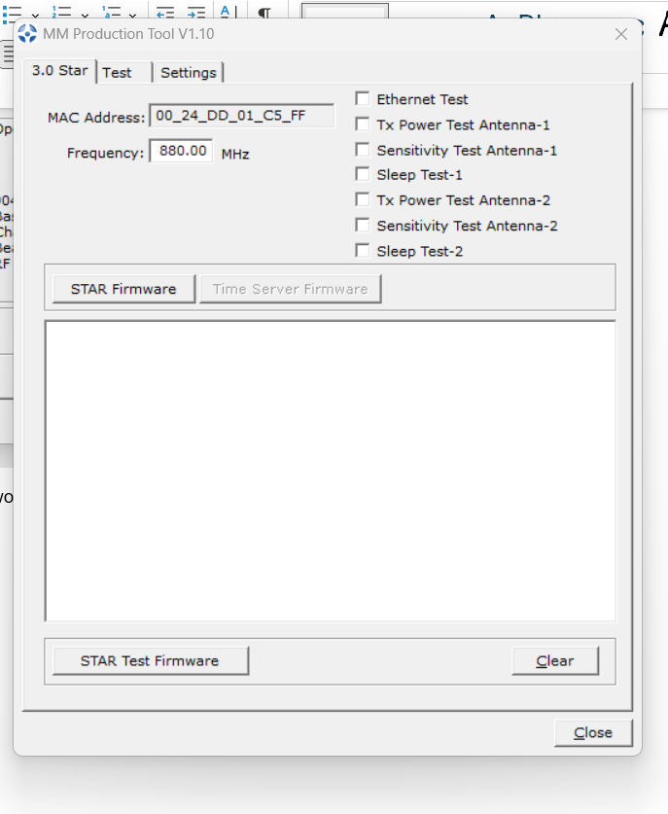

Check all available boxes
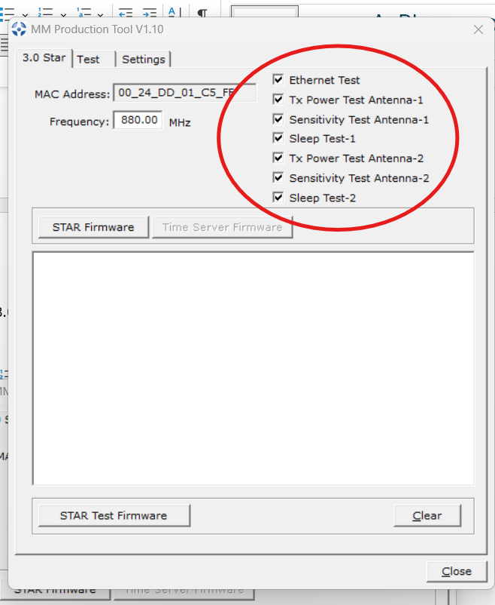

Click on Star firmware option and Release tool hardware Red LED starts blinking while flashing

After Successfully flashing the Star
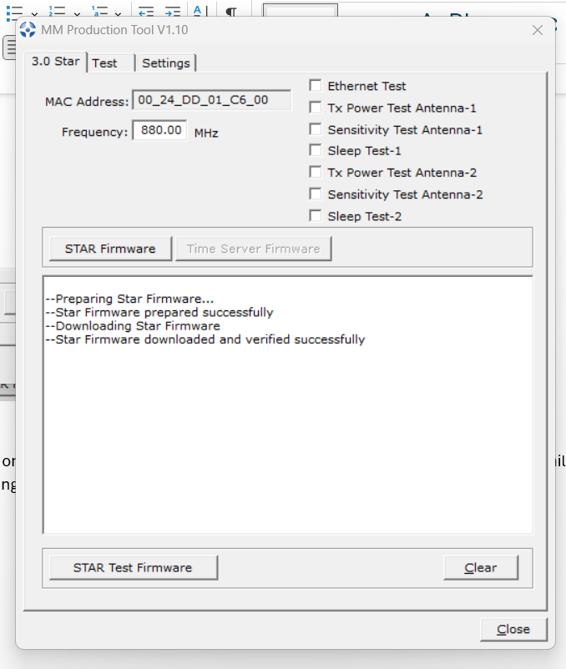

While flashing Time star firmware below option should be enabled instead of Star firmware
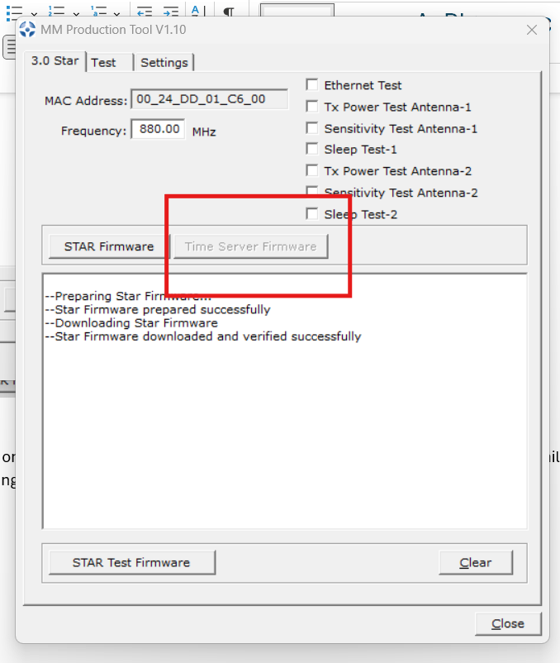

Once after successfully flahing the Star we can make sure the version in below option
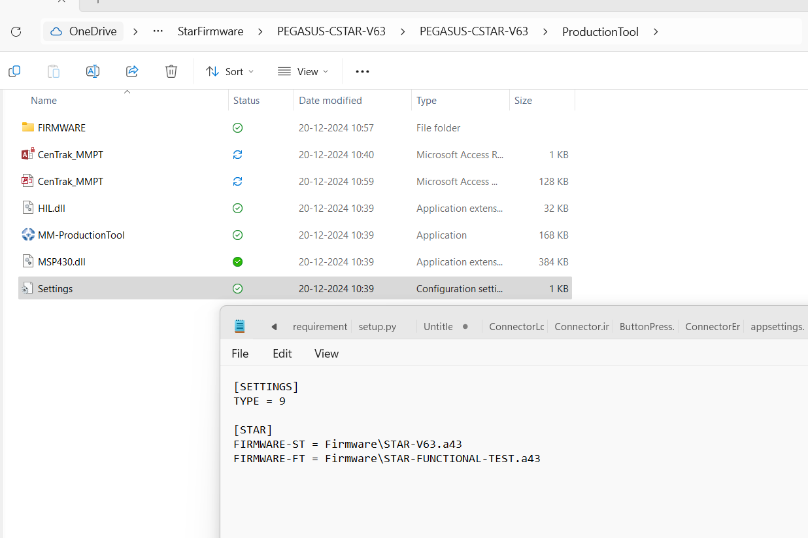

Copy the OTA files c\centrak\firmware folder

In Local streaming client tool Goto command options in the left bottom corner

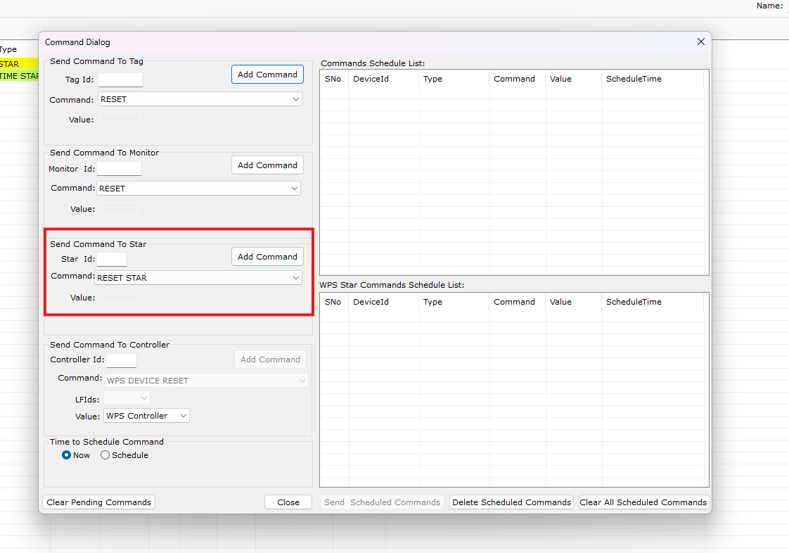

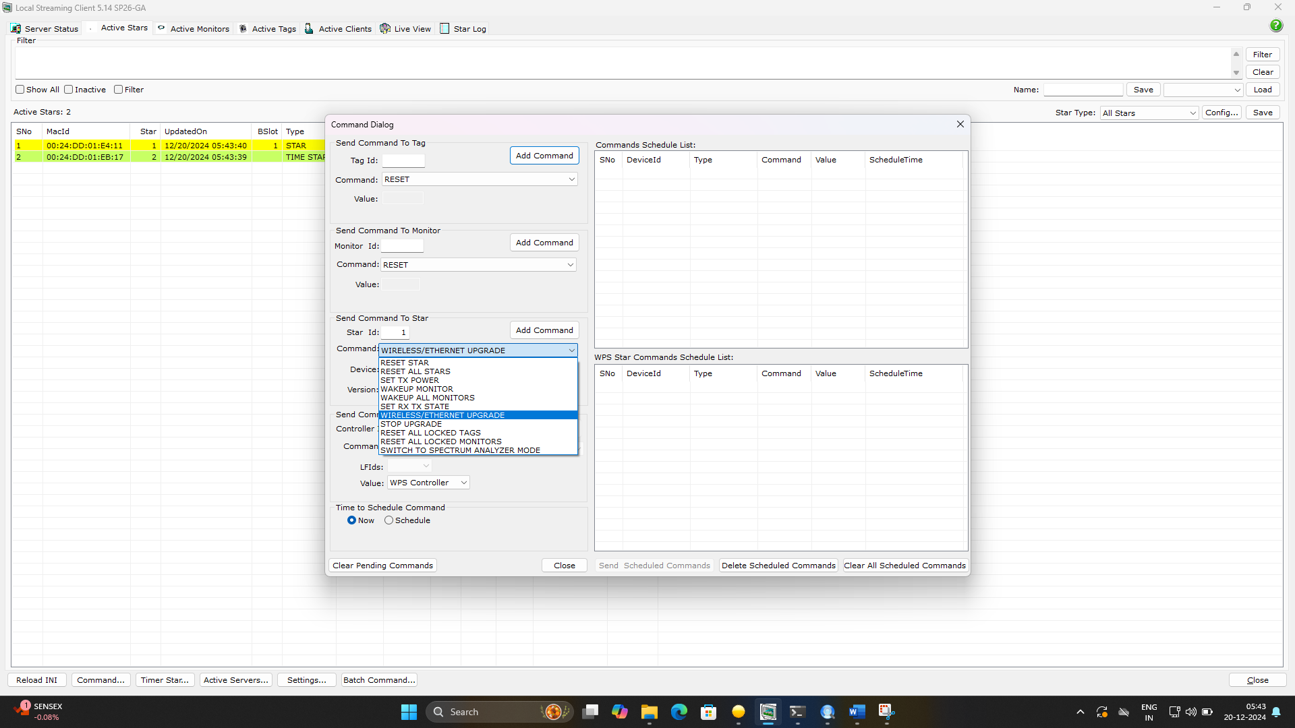

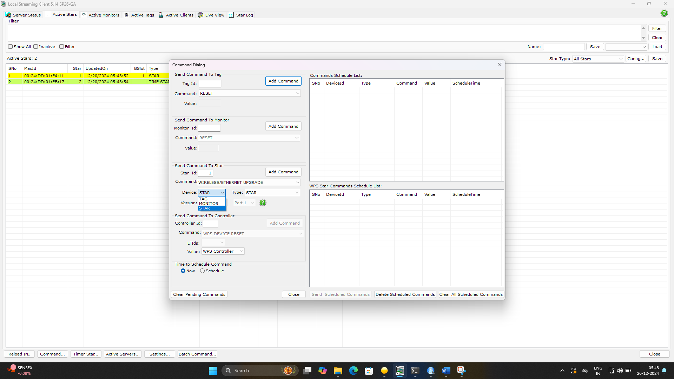
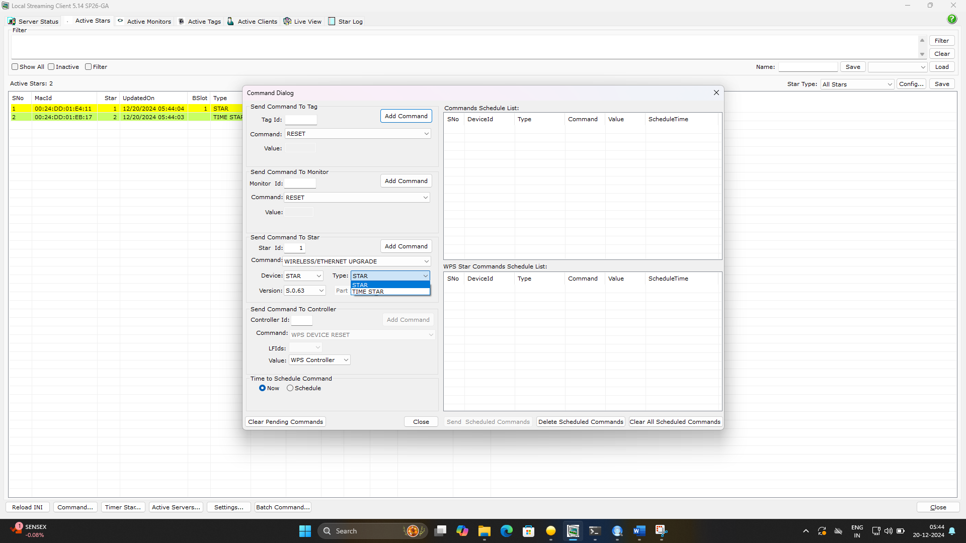
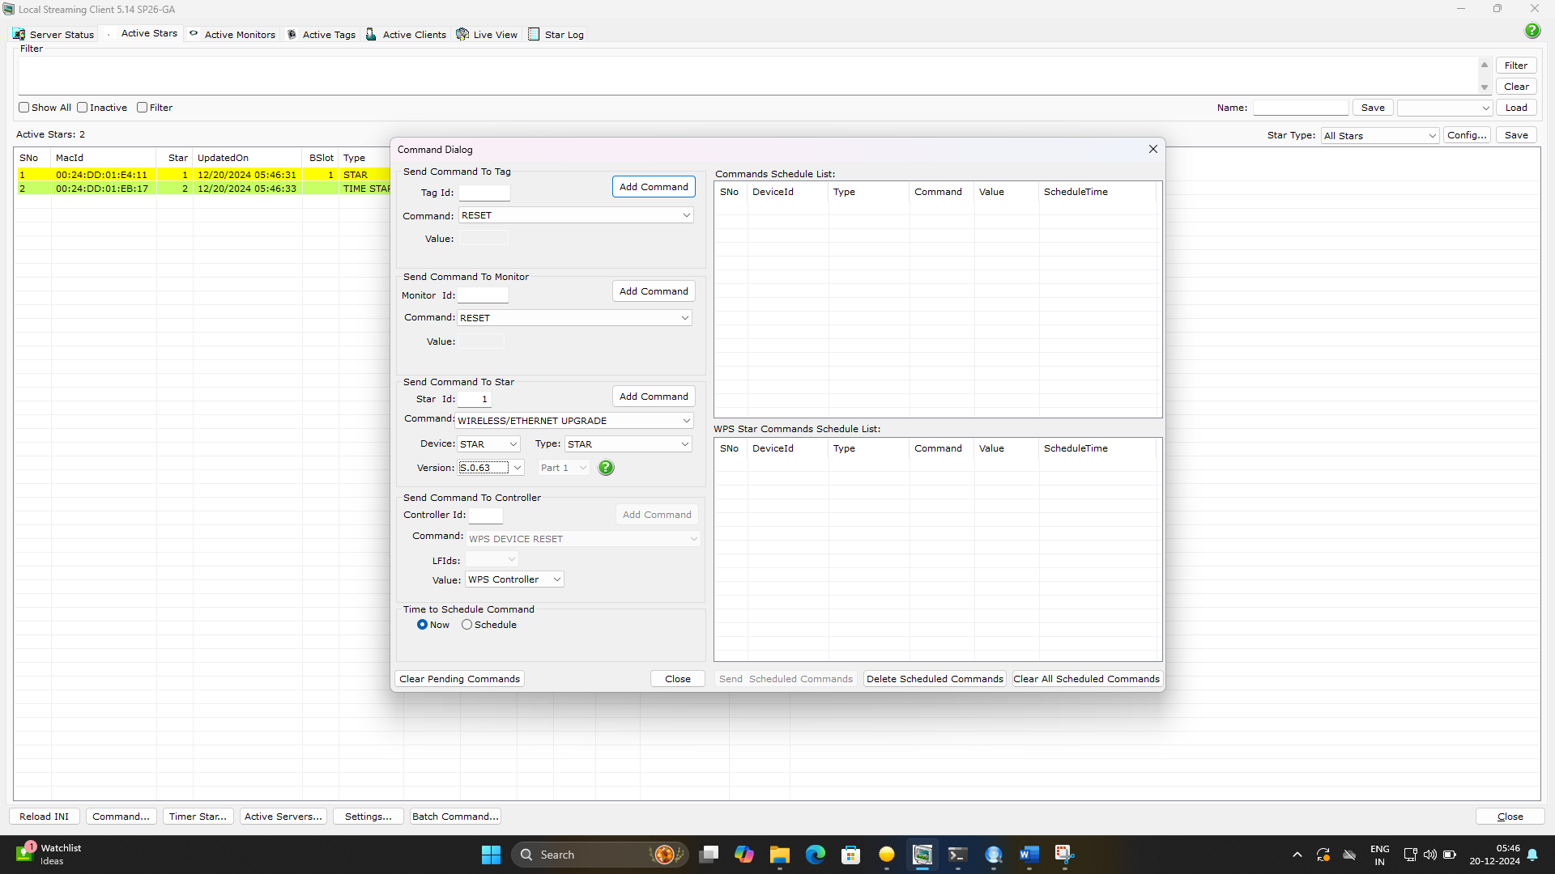
Click in addCommand
Upgrade will start and displays upgrader in Star row and color changes to blue
